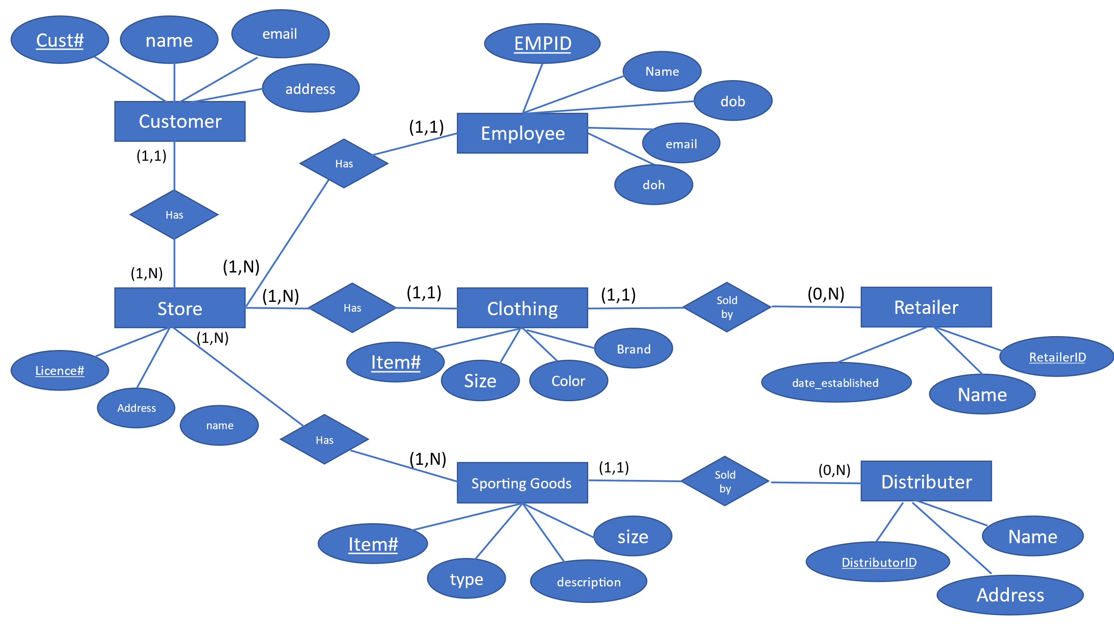

**Problem Statement:**

* Write down the complete relational model for this problem.
* Describe the application domain (from a business interpretation).
* State one inherent assumption about the application.
* State one query that would be important, but that you cannot answer using this model. Then state how you would modify the conceptual model so that this question could be answered after the relational model has been implemented.

**Ans:)**

1. **Relational Model:**

CUSTOMER (Cust#, name, email, address, *License#*)

EMPLOYEE (EMPID, name, email, dob, doh, *License#*)

STORE (Licence#, address, name, *EMPID*)

CLOTHING (Item#, brand, size, color, *RetailerID*)

DISTRIBUTOR (DistributorID, name, address)

RETAILER (RetailerID, name, date_established)

SPORTING GOODS (Item#, type, description, size, *RetailerID, DistributorID)*

SALE (SaleID, Cust#, EMPID, Store#, Item#, RetailerID, DistributorID, date, price)

CUSTOMER (Cust#) 1--N SALE (Cust#)

EMPLOYEE (EMPID) 1--N SALE (EMPID)

STORE (Store#) 1--N SALE (Store#)

CLOTHING (Item#) 1--N SALE (Item#)

SALE (SaleID) 1--N DISTRIBUTOR (DistributorID)

SALE (SaleID) 1--N RETAILER (RetailerID)

1. The relational model presented here pertains to a retail establishment specializing in the sale of apparel and athletic goods. Within this domain, customers have the capability to log their purchases during their shopping experience, facilitated by store personnel who handle the sale of merchandise. The retail outlets themselves are owned by a larger retailer entity that specializes in supplying sporting goods. Additionally, distributors play a role in supplying apparel inventory to these retail stores, thereby contributing to the overall operations of the establishment.
2. One inherent assumption about the application is that **each sale is for a single clothing item**. In actual case, it might not be the same and a sale can have multiple clothing items.
3. One query that would be important, but that cannot be answered using this model, is "**What is the average amount spent by customers from each city?".**

The conceptual model could be modified to include a city attribute in the CUSTOMER table. The relational model would then be:

CUSTOMER (Cust#, name, email, address, dob, **city**)

EMPLOYEE (EMPID, name, email, dob)

STORE (Store#, address, date_established, name)

CLOTHING (Item#, brand, size, color)

SALE (SaleID, Cust#, EMPID, Store#, Item#, RetailerID, DistributorID, date, price)

DISTRIBUTOR (DistributorID, name, address)

RETAILER (RetailerID, name, address)

CUSTOMER (Cust#) 1--N SALE (Cust#)

EMPLOYEE (EMPID) 1--N SALE (EMPID)

STORE (Store#) 1--N SALE (Store#)

CLOTHING (Item#) 1--N SALE (Item#)

SALE (SaleID) 1--N DISTRIBUTOR (DistributorID)

SALE (SaleID) 1--N RETAILER (RetailerID)

With this modification, the query "What is the average amount spent by customers from each city?" could be answered by:

SELECT c.city, AVG(s.price)

FROM CUSTOMER c

INNER JOIN SALE s ON c.Cust# = s.Cust#

GROUP BY c.city;